Kubernetes Activity 2 :

Change port to 5000 from 3000 in the client-deployment.yml file

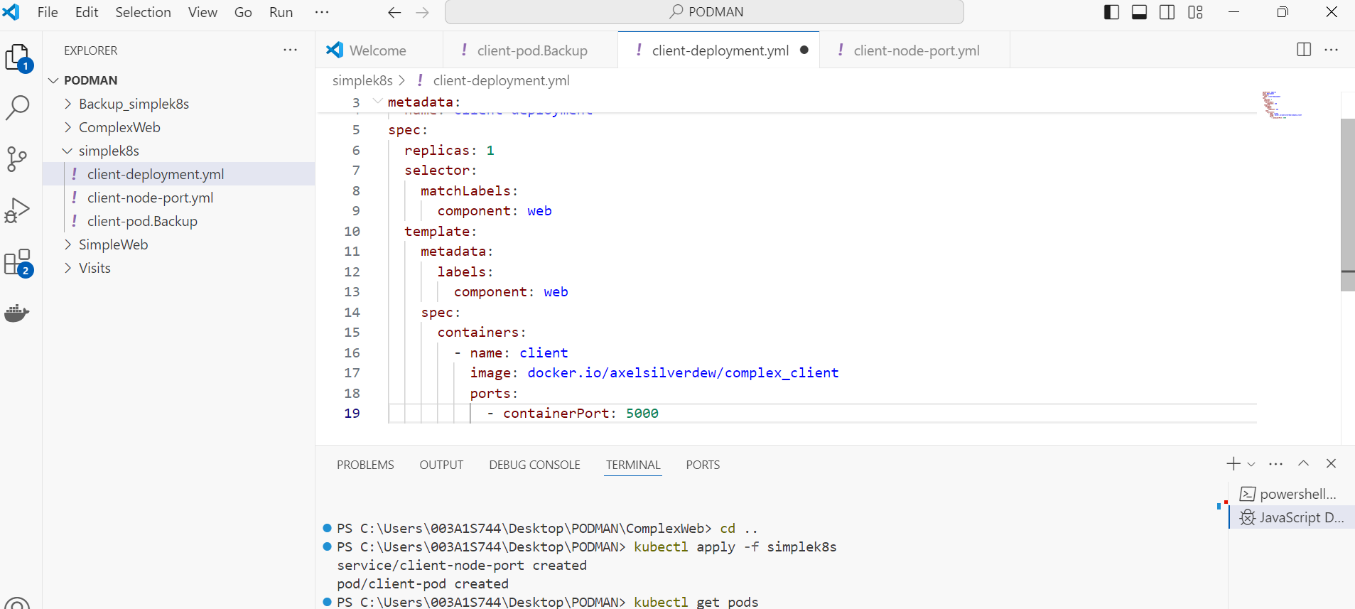

Also change the target port to 5000 in “client-node-port.yml” file

Now run the command “kubectl apply -f simplek8s” in visual studio

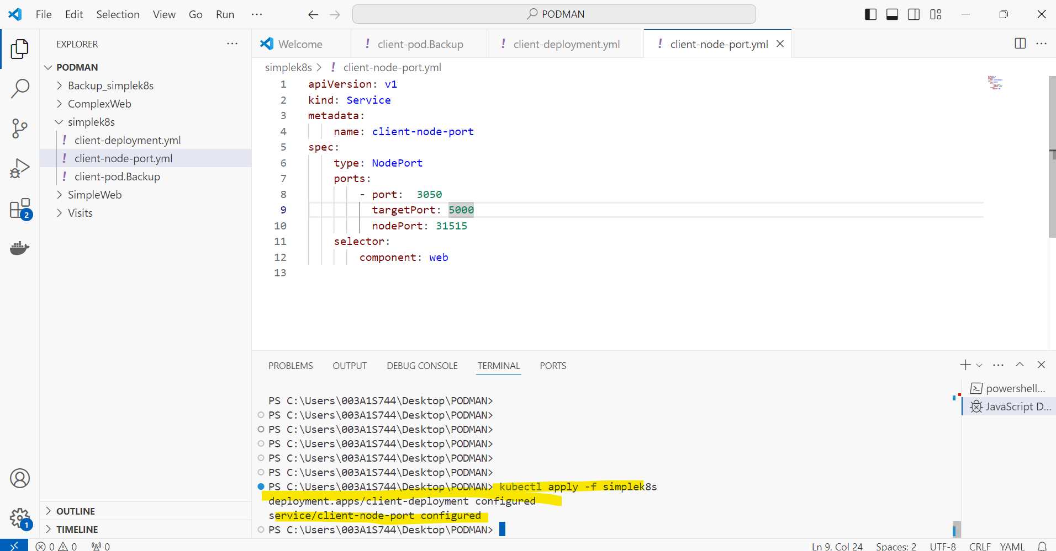

Open powershell, run the following command “kubectl describe pod client-deployment”, you can see the port changed to 5000 from 3000

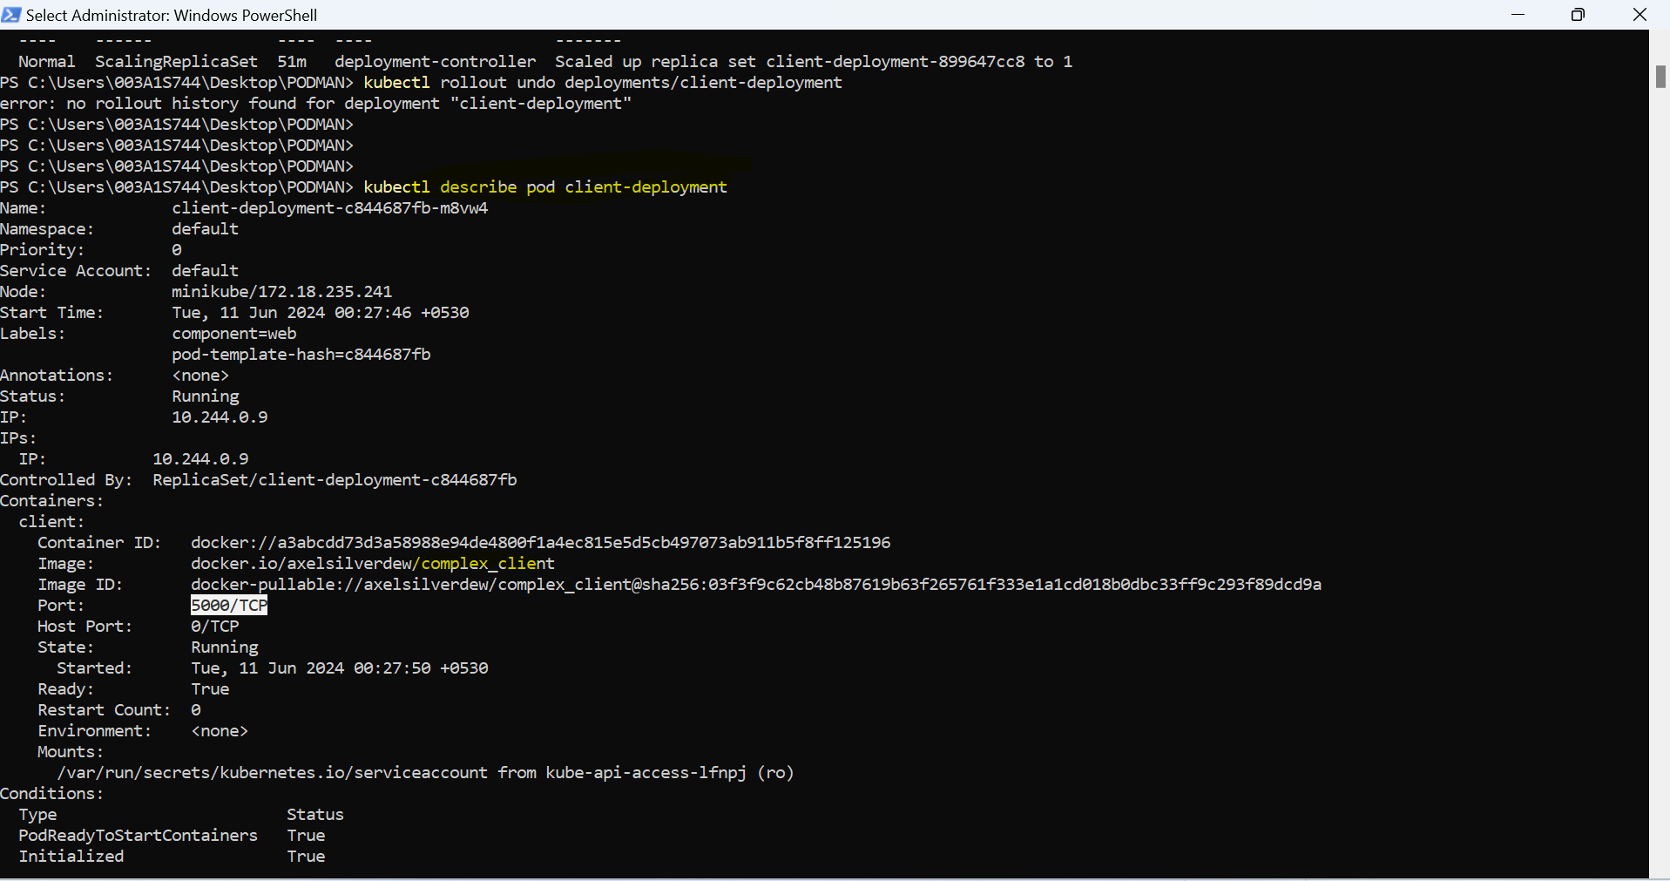

Now if you want to rollout the changes done execute

--kubectl rollout undo deployments/client-deployment

Now describe the client-deployment pod in powershell, port again changed from 5000 to 3000

--kubectl describe pod client-deployment

